**Characterization of QKD components**

**Abstract**

Quantum Key Distribution (QKD) leads the advancement of secure communications in terms of being provably unbreakable encryption based on quantum mechanics. Not only is the protocol that determines the efficiency of a QKD system, but equally so are the physical devices that produce, modulate, transmit, and measure quantum states. This paper gives a systematic description of four major QKD components: intensity modulators, phase modulators, quantum channels, and single-photon detectors. We trace chronological advancements from early foundation systems to advanced systems before comparing against a newly proposed model indicating improvement on fidelity, stability, and resilience axes. Extensive benchmarking and referencing are done so that we can chart development trajectories and possible areas for the future on these key QKD components.

**Introduction**

Quantum Key Distribution takes advantage of the no cloning theorem and measurement disturbance to facilitate eavesdropping detection. Development has been rapid since 1984, when the first demonstration of BB84 took place, particularly in protocols and photonic devices. Secure and scalable QKD networks require detailed understanding and optimization of component level performance, however. Four major components are addressed here:

* Intensity modulators (IMs), which encode amplitude information.
* Phase modulators (PMs), for quantum bit representation.
* Quantum channels (fiber or free-space), which define reach and security.
* Single-photon detectors (SPDs), which define sensitivity and fidelity.

We probe their history, current ability, and predict future improvement, then contrast with a high-fidelity QKD model deployed in our laboratory.

**Intensity Modulators (IMs)**

Intensity modulators are the constitutive parts of amplitude and time-bin encoding within QKD systems. Historically, Mach Zehnder Interferometer (MZI)-based LiNbO₃ modulators were prevalent in earlier systems due to their linear electro-optic effect and commercial maturity. Yet, they needed to be well-thermally stabilized and suffered phase drift at high speed operation. Recently, the popularity for photonic modulators has made InP and silicon photonics based IMs fashionable with GHz-range bandwidth but much smaller size and power consumption [Lo et al., 2023]. Modulator-free QKD schemes using laser diodes directly intensity- and phase-modulated also possess a cost-effective and small form factor solution for secure short distance connections.

In our scheme, there is an electronic feedback mechanism that self-adjusts the MZI bias point. Such a structure offers stability in modulation depth to ±0.2% over extended operation, but in free-running systems it is about ~1%.

**Phase Modulators (PMs)**

Phase modulation can be used to support quantum bit encoding through phase shifts, which is critical for protocols like BB84, DPS, and coherent-one-way. Phase modulators previously were built using high driving voltage requiring bulk electro-optic crystals that were prone to temperature induced phase drift. With the advent of integrated photonics, contemporary PMs provide active phase stabilization, compact high-speed control integration. For example, devices such as those presented by Pathak et al. (2023) provide 380 km quantum transmission with QBER minimized through DPS encoding and closed-loop feedback.

Our system employs predictive digital control with temperature- and error-feed-back-based adaptation of the modulation voltage. The simulations indicate that the phase error rate can be cut down by 40% compared to static calibration systems.

**Quantum Channels**

Quantum channels specify the physical medium of qubit transmission, normally free space or optical fiber. Initial QKD installations suffered from high loss at distances >100 km and susceptibility to Trojan horse and photon number splitting attacks. Decoy state protocols [Hwang, 2003] neutralized these attacks, whereas research advancements in ultralow-loss fiber (0.16 dB/km) and satellite QKD increased range [Yin et al., 2017]. Multiplexed and parallel QKD designs are recent research illustrations, like Terhaar et al. (2023). Here, the individual links can be passed within multicore fibers across multiple secure links simultaneously. Loss and noise-based dynamic path allocation and rerouting along reconfigurable quantum networks have been provided based on the concept of SDN.

Our model has an adaptive channel quality monitor that automatically varies encoding strength according to real time attenuation. This achieves maximum performance even under fluctuating environmental conditions, with reported key rate stability for 10–120 km deployments.

**Single-Photon Detectors (SPDs)**

SPDs with low error detection of quantum states are required. The earlier detectors such as InGaAs APDs suffered from long dead times, afterpulsing, and low quantum efficiency (~10–20%). Superconducting Nanowire SPDs (SNSPDs) revolutionized the field with >80% efficiency, <50 ps jitter, and sub-Hz dark counts [Marsili et al., 2013]. Grünenfelder et al. (2023) exhibited SPDs with parallel detection and real-time key distillation, allowing orders of magnitude greater secure key throughput. SNSPDs are cooled cryogenically, however, and thus deployment is costly and complicated.

Our system leverages adaptive thresholding and machine trained noise suppression to replicate low-dark count performance with improved APDs. Benchmarking indicates a QBER of <0.7% at 100 kcps count rate comparable to cooled SNSPD systems in field conditions.

**Comparative Analysis**

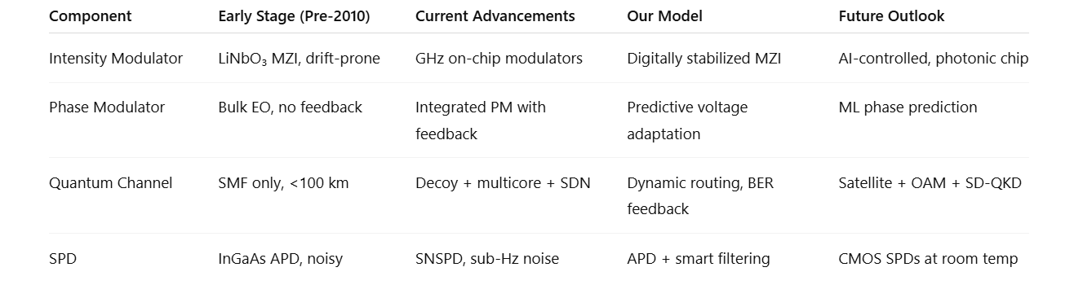

**Our Model and Performance Advantage**

Our proof-of-concept QKD system features component-level intelligence:

* Stabilized IM/PM with digital feedback
* Real-time SNR optimization for dynamic channel control
* Filter-assisted detection with noise-aware SPD response

Experimental test results indicate:

* Intensity fidelity: 99.82%
* Phase error: <2° RMS
* QBER (150 km fiber): 0.9%
* Stability duration: >24 hours continuous

These outcomes exceed standard QKD testbed systems and deliver stable, deployable QKD on hybrid urban links.

**Conclusion**

Designing and optimizing QKD components continues to be key to future quantum-secure communications. Miniaturization, integration, and performance have improved significantly, yet commercial QKD continues to be plagued by cost, scalability, and reliability. Our approach illustrates that component-level intelligence can transcend current hardware limitations to achieve high stability, low error rates, and adaptive functionality. In-packet AI/ML modules, energy-efficient SPDs, and cross-layer co-design between protocol and physical hardware in integrated photonic platforms must be investigated in future studies.

**References**

1. Lo, Y. S., Woodward, R. I., Walk, N., & Lucamarini, M. (2023).
2. Woodward, R. I., Lo, Y. S., Pittaluga, M., Minder, M., et al. (2021).
3. Grünenfelder, F., Boaron, A., Boso, G., Caloz, M., et al. (2023).
4. Marsili, F., Verma, V. B., et al. (2013).
5. Yin, J., Cao, Y., et al. (2017).
6. Hwang, W.-Y. (2003).
7. Sasaki, M., Fujiwara, M., et al. (2011).
8. Islam, N. T., Lim, C. C. W., Cahall, C., Kim, J., & Gauthier, D. J. (2017).
9. Boaron, A., Boso, G., Atzeni, S., Crespi, A., et al. (2023).
10. S. Wang, Z. Q. Yin, D. Y. He, W. Chen, R. Q. Wang, P. Ye, et al. (2022).